

**HUMAN COMPUTER INTERACTION [BM]**

**PROJECT REPORT**

**DATE: 07 January 2020**

**“PLAN EVE”**

**TEACHER:**

**MS NAZISH NOMAN**

**STUDENT:**

**SYED DANISH ALI FA16-BSCS-0038**

**ZAUFISHAN HASSAN FA16-BSSE-0028**

**HARIS KHALID SP17-BSSE-0046**

**M.ABDULLAH WASEEM SP17-BSSE-0060**

Table of Contents

1. Introduction: 2

1.1 Problem Statement: 2

1.2 Proposed Solution/Existence System: 2

1.3 Product Scope: 2

2. Overall Description 3

2.1 Product Perspective: 3

2.2 Product Functions 3

2.2.1 For clients: 3

2.2.2 For service provider: 3

2.2.3 Management Team of Plan Eve: 3

2.3 System Features: 4

2.4 Functional Requirements 4

2.5 Other Nonfunctional Requirements 4

2.5.1 Performance Requirements 4

2.5.2 Safety Requirements 5

2.5.3 Security Requirements 5

2.5.4 Software Quality Attributes 5

2.6 Gap Analysis: 6

2.7 STAKEHOLDERS: 6

3. CONTEXTUAL INQUIRY: 6

3.1 Problem: 6

3.2 Solution: 6

3.2.1 Target Users: 7

3.2.2 Venues: 7

3.2.3 Working type: 7

3.2.4 Experience level: 7

3.2.5 Meet the service providers and service seekers: 7

3.3 Contextual Inquiry – Interview Descriptions 7

3.3.1 Process and environment: 7

3.3.2 Service Seeker gave us these recommendations: 8

3.3.3 Service Provider gave us these recommendations: 8

3.3.4 Expected Benefits: 8

3.4 Task Analysis Questions: 9

4. The Pact Analysis: 10

4.1 People Analysis: 10

4.1.1 The Primary Stakeholders (Directly uses the system): 10

4.1.2 The Secondary Stakeholders (Use occasionally or through an intermediary): 10

4.1.3 Physical Aspects: 10

4.1.4 Psychological Aspects: 11

4.2 Activity Analysis 11

4.2.1 Temporal Activity: 11

4.2.2 Co-operative Activity 11

4.2.3 Complex Activity 11

4.2.4 Safety critical Activity 12

4.2.5 Nature of content 12

4.3 Context Analysis: 12

4.3.1 Physical Context: 12

4.3.2 Social Context: 12

4.3.3 Organizational Context: 12

4.4 Technology Analysis: 12

5. User Survey Techniques and Results: 13

5.1 Client: (Service Seeker) 13

5.2 Service Provider: 14

6. USER PROFLE: 16

7. Storyboard Design: 18

8. Hierarchical Task Analysis Diagram: 20

9. Interactive Prototype: 21

9.1 Evaluation of Prototype: 24

# Introduction:

The aim of this web application is to provide all the facilities regarding an event. From reserving a venue to book, caterers, decoration etc. As we know, whenever we organize an event there are a lot of things which a person must manage, and it becomes hectic to manage all the activities like visiting the venue and choosing it. Then selecting an appropriate catering service.

## Problem Statement:

Arranging a corporate event is becomes a massive task these days, why do people say that? because planning an event requires a lot of energy, time, and a lot of money.

## Proposed Solution/Existence System:

To solve this problem, we have a web-based application called “Plan Eve” which is specializes in event management and serves its customers in an extraordinary manner to make them understand that it is working according to your desires. All our packages completely fit into every person pocket. Our services are available with economical price range, so if you want to decorate your memorable event, then get pleasure from the services we offer that are designed according to your wishes or you can share your own ideas with us, as well.

If you are planning any type of event, your engagement, wedding, co-operative event, get together parties, birthday events, musical evenings, special family occasions, simply all events in Karachi. As Plan Eve is an event management company in Pakistan so that it can also help with managing your special events.

Currently there are no project available of this domain.

## Product Scope:

This project “Plan Eve” introduces that by sitting at home User can see the details, user can reserve a venue and other services related to an Event, user can give feedback, user can communicate with provider. User gathered all appropriate information about best venues all over the Pakistan according to your budget and all your needs like Banquet halls and Lawns in Karachi, Lahore, Quetta and other cities in Pakistan. Service provider have their own account in which they can update the details of its services like images, video, price etc. In this project there a referral system in it there are two categories in this system one is top rating those service providers who have top rating will show on the top of the list and second is promotion category those service providers who will pay us for advertisement will be shown on the top.

# Overall Description

## Product Perspective:

This system consists of web portal, that portal is used by client, service and Management staff of organization who owns this project. User can get information about the venue, catering, decoration, price, capacity and many other things by sitting at home. And Service provider have their own account in which they can update the details of its services. Data will be stored in a database from where management team of Plan Eve will use database to add, modify and delete data.

## Product Functions

### For clients:

* Client give its information like at what date they want a venue, no of guest, range and

Location where they want a venue.

* Client can see Venues images, Location and other facilities which are related to the venue.
* They can book other services like catering, decoration. They can also see their details from this portal.
* A Client will give feedback/rating after the completion of event.
* Client can reserve the venue and other services by early booking.
* Client can communicate with the provider through expert system.
* Expert system will give guidance to the client.

### For service provider:

* Venue Provider: Provider can update its venue details, images, 3D motions, price, booking dates, location, facilities and no of guest they offered.
* Catering Provider: Provider can update its menu, dish price.
* Decoration Provider: Provider update its decoration theme and details about the theme.
* Expert system will communicate with the provider

### Management Team of Plan Eve:

* Management team can record how many clients can reserve a venue and other services by using their portal.
* Management team can see client can seek services from which service provider.
* Management team can tract the status of a booking.
* Management team can arrange service provider’s position based on rating and promotions.
* Management team can confirm the reservation.

## System Features:

* client enter the details
* client can see the details
* Registration
* login
* client can reserve a venue
* client can reserve other services
* Expert system opinion
* Service provider can update the details.
* feedback
* logout

## Functional Requirements

* Enable the client to enter the information regarding the venue or other services.
* Enable the client to fill filter form
* Client can see the details according to its requirements rather than going to the physical location.
* The client can login the system if he is registered in the system.
* Client can book a venue by staying at home rather than going to the venue or other services and book it.
* Providing client, the facility of expert system opinion which will guide the client according to its needs. Expert system communicates with the service provider and then confirm the client about its request.
* To provide secure venue, preventing any disruption from external entity.
* To check the amount related to the venue or other services.
* Expert system will guide the client.
* Send the request to the expert system for the reservation.
* Expert system will communicate with the service provider for the approval.
* Admin manage the position of service provider in referral system.
* Client can communicate with the service provider through expert system.
* After the complication of the event client can give feedback to the service provider.
* Client can see the availability of the venue.

## Other Nonfunctional Requirements

### Performance Requirements

System updates every 5 minutes, so any changes or status can be updated efficiently.

### Safety Requirements

This system ensures that the service provider would be real, we will also ensure that the client will submit the advance money.

### Security Requirements

Login and password of the client is required. The data of client is only visible to the admin and not to anyone else. In case of data we deliver to an unauthorized user the client will be notified.

### Software Quality Attributes

* Usability requirements: Both the client and service provider can use this portal to monitor but an employee cannot make changes after work time.
* Operational requirements: portal is capable of handling thousands of request at a time means at one time the portal is capable to perform either data entries or retrieve once. Requests more than one thousand will be placed in queue so that as soon as one user closes its operation others can continue with his own.
* Availability: The system shall be available 97% in a year and will be shut down for at least 4 hours on Sunday morning from 6 am to 9 am twice a year.
* Testability: system is easy to test it can also be divided in different modules so that it is easier for testing.
* Adaptability: the system is smart enough to change the behavior according to client’s need.
* Flexibility: This system is flexible enough that when we make changes in it, it will adapt easily.
* Correctness: the correctness of our web portal is almost 100%. Each time the client will make a request like reserve a venue or other services so it will get the correct out.
* Interoperability: This web portal is design for windows users but it can be run on any other operation system like Ubuntu, Mac in tosh etc.
* Maintainability: In this web portal the faults can be modified easily. The changes in the system or components are easily changeable.
* Portability: wither we run this web portal in laptops, mobile phones or any other gadgets it will run smoothly.
* Reliability: This web portal is reliable enough that it will give the correct output at any time when it is used, client can make a request at 4 am or 4pm this system will respond quickly.
* Reusability: From this web portal the new features can be introduced with ease using the components from the existing system.
* Robustness: there would-be drop-down option if the client select the wrong option then the system would still work correctly.

## Gap Analysis:

As there is no project or application available of such domain, we cannot analyze the gap between the existence system and our proposed solutions.

## STAKEHOLDERS:

* Client (Service Seeker)
* Service Providers
* Admin

This system provides service seeker all the details regarding the venue so that he can gather information and then can reserve a venue for any event by just sitting at home rather than going to check the venue and then visiting caterers, decorators and other people which waste a lot of user’s time. Service provider can also update their price and can upload images so that client can contact them. This provides them a business opportunity.

No, system uptil now has been made of this type.

# CONTEXTUAL INQUIRY:

## Problem:

Arranging a corporate event is becomes a massive task these days, why do people say that? because planning an event requires a lot of energy, time, and a lot of money.

## Solution:

To solve this problem, we have a web-based application called “Plan Eve” which is specializes in event management and serves its customers in an extraordinary manner to make them understand that it is working according to your desires. All our packages completely fit into every person pocket. Our services are available with economical price range, so if you want to decorate your memorable event, then get pleasure from the services we offer that are designed according to your wishes or you can share your own ideas with us, as well.

If you are planning any type of event, your engagement, wedding, co-operative event, get together parties, birthday events, musical evenings, special family occasions, simply all events in Karachi. As Plan Eve is an event management company in Pakistan so that it can also help with managing your special events.

### Target Users:

Only users and venders were interviewed for this project. The following parameters were taken into considerations when choosing interviewees.

### Venues:

It is important to know the difference between how larger and smaller venues operate in order to implement and adaptable system efficiently. Our choice of interviewees came from two different sized venues: a smaller one which does not provide other services like catering, DJ, accommodation, photography etc., and a larger one which provide all other services.

### Working type:

There may be different views among users, venders. Our interviewees held the following positions: international users and local users, venders.

### Experience level:

We wanted to view the problem from different levels of experience. More experienced venders could possibly be too comfortable with the existing system and not want to change anything. Less experienced venders could have better ideas than more experienced ones.

### Meet the service providers and service seekers:

We interviewed service providers and service seekers by which we get the idea what difficulties they face every time to book a venue and provide other services according to seeker requirements.

## Contextual Inquiry – Interview Descriptions

### Process and environment:

The interviews with service providers and service seekers were conducted at the office. The interviews were conducted by two people: one person asking questions mainly, and the other typing the rough idea or answer from the seekers using laptop. The interviews start by asking the service providers what difficulties they might face during booking or organizing any event or while providing services to the seeker according to their budget plan and what are the pros and cons to do all hard work manually. We asked the service seekers how they manage to book any venue, what problems they usually face while booking any venue, which parameters they think is the most important to book any venue according to budget and how they seek other services. From here, we get lots of unexpected information.

Common Tasks and Themes:

A seeker has my problems while organizing an event like first he must decide the venue by keeping in mind his budget then after that visit the venue to finalize it, then again visit it to give advance money. This is only the first step after that he must visit the caterers and decorator and many other things, he must look in.

The service provider also deals with many different types of clients and convincing them wit in their budget is the most difficult task for them.

Unique Features of Different Interviews:

Service seeker were very happy with this project, as it saves a lot of time and they also don’t have to deal with many other people but by this application with just the system.

### Service Seeker gave us these recommendations:

* The budget should be user friendly so that all users can easily afford it.
* The services provided through this system should work efficiently.

### Service Provider gave us these recommendations:

* The system should provide the surety and assurance so that it can be trusted.

### Expected Benefits:

* More users will use this application.
* The time will be saved through this system of both the service seeker and service provider.
* More employment opportunities for the service providers.
* Service providers don’t have to deal with daily calls from the clients.

## Task Analysis Questions:

Q1: Who is going to use this system?

Ans: Service seeker (client), service provider and system admin are going to use this system.

Q2: What tasks do they perform now?

Ans: People don’t know details about the venue, catering, decoration and other services, to know this information they must visit them and collect information like amount, availability, capacity etc.

Q3: What tasks are desired?

Ans: This system takes care of user’s needs, approaches and complications that user need to face before the event. By just sitting at home user can see the details. User can reserve venue and other services related to the event. User can communicate with service provider, user can gather appropriate information about any venue. Service providers from their own account can update the details like pictures, videos, prices etc.

Q4: How are tasks learned?

Ans: There will be a tutorial from where user can learn how to perform a task easily.

Q5: Where are the tasks performed?

Ans: The tasks are performed on the web portal.

Q6: What’s the relationship between user and data?

Ans: Service seeker and data: Seeker give its requirements through a filter form.

Service provider and data: Provider give its data in the form of price, images, videos related to its services.

Q7: What other tools does user have?

Ans: User may have mobile phone/laptop/computer

Q8: How do users communicate with each other?

Ans: Users communicate with each other through expert system. As service seeker and provider can’t communicate directly with each other, so they communicate through expert system.

Q9: How often are tasks performed?

Ans: The task is performed 99% of the time accurately. Task fails if a user's internet connection is down or any other internal problem. Rest of the time tasks are performed accurately. At a time more than 1000 venues can be booked.

Q10: What is the time constraint on the task?

Ans: After reserving the venue the client needs to give payment within 2 days of the booking otherwise the booking will be cancelled. If a client wants to cancel the booking so it must do it with in 1 day, after the booking else no money would be return back.

Q11: What happens when the things go wrong?

Ans: There are many things that can go wrong:

If internet is not available, if venders’ profile isn’t updated. If a person does two bookings at a time. If system crashes.

# The Pact Analysis:

## People Analysis:

Some of the Stakeholders are:

### The Primary Stakeholders (Directly uses the system):

* Common people (who reserve venue and other services)
* Service provider (who updates the detail of its services)
* Designer – Frontend.
* Developers – Backend
* Admin who verify accounts.
* Database Administrator – Maintaining Database and Updating Database.

### The Secondary Stakeholders (Use occasionally or through an intermediary):

* Event Management.

### Physical Aspects:

Physical differences have a huge impact on making design and decisions on accessibility and usability for the system.

* Age: All the stakeholders are 18+.
* Gender: Both male and female are included among stakeholders.

#### Physical Ability:

This application is for those who are normal.

### Psychological Aspects:

The users are mostly senior citizens and people suffering from amnesia, they might not be too educated but they must know how to use android phone. Our app has focused on the learnability aspect to guide user using tutorials to make user familiar about how the app works and what functions can be performed using different buttons. In this way, it will be easy for user to adapt changes in the upcoming versions of the app. The UI of the app focuses more on following the correct conventions of mapping. The user should not get frustrated he could see.

#### Social Differences:

English would be the common communication language among all the stakeholders, and we facilitate Urdu language as well.

## Activity Analysis

### Temporal Activity:

* This system frequently used more than once in a day.
* This system is no single time activity; 1-2 days require for it.
* This system is continuous.

### Co-operative Activity

* Factors will involve in it like decorators, caterers etc.

### Complex Activity

User can easily learn from the system when he will login the system three options appeared in the screen of date, location and category of event user just has to enter the details further details will be appeared in the screen according to its details.

### Safety critical Activity

When user will reserve an event so confirmation message will generate.

### Nature of content

Every type of data will be there.

## Context Analysis:

### Physical Context:

User can use this system wherever he wants to use it only internet should be available for it.

### Social Context:

The user’s data wouldn’t lose, privacy is in it, things are same as in pictures

### Organizational Context:

By using this system communication gap will be decrease, by using this technology you can see the details reserve the venue or other services by sitting at home.

## Technology Analysis:

This is a web-based application

Input: user can input its details

Output: details of the services according to its details.

We use these technologies:

|  |  |  |
| --- | --- | --- |
| Technology | Advantage | Disadvantage |
| React JS | Updates process is optimized and accelerated | Learning curve. Being not full-featured framework, it is required in-depth knowledge for integration user interface free library into MVC framework. |
| Firebase | Unless your app runs of one centralized database updated by a vast quantity of users, it's a major overkill. | If your app does run of a centralized DB and is updated by a lot of users - then it's more than capable of handling the Real-Time data updates between devices. |
| CSS | Help to Make Spontaneous and Consistent Changes | It is vulnerable. |
| HTML | First advantage it is widely used. Every browser supports HTML language. | It can create only static and plain pages so if we need dynamic pages then HTML  is not useful. |
| BOOTSTRAP | A consistent framework that supports major of all browsers and CSS compatibility fixes. | There will be requirement of lots of style overrides or rewriting files that can thus lead to a lot of time spent on designing and coding the website if the design tends to deviate from the customary design used in Bootstrap. |

# User Survey Techniques and Results:

## Client: (Service Seeker)

Q1: How do you gather the information regarding a venue?

Ans1: I tell my wife about the venue which I have searched, or I have heard it from someone/I have experienced it. She also does the same and she is the only one to give the final approval. It doesn't matter what I think.

Q2: How much time earlier do you have to book a venue?

Ans2: A lot earlier as possible, 5-6 months.

Q3: What difficulties you face while reserving a venue?

Ans3: My wife's mind, which thinks too much in these kinds of matters. She confuses and makes me confuse also. When she says venue 'A' looks good to me, I say ok, let's finalize it. Then suddenly her mind changes, and she says venue 'B' looks good. It continues ...

Q4: What things are required for you to do an event? That should be necessary for the event without which event is incomplete?

Ans 4: Planning, Decision Making, Bird's eye view and Patience.

Q5: How do you identify that if a venue is available on the date you want or not?

Ans 5:  Searching on internet / On-Call.

Q6: How do you contact catering, decorators and other services that are required for an event?

Ans 6: Usually By visiting the catering or sometimes on call.

Q7: How difficult is it to find the venue according to your budget?

Ans 7:  I think it's not too difficult, there are a lot of options we can make according to our budget.

Q8: If a system is built in which all the things regarding reserving to contacting service providers are there. Would you use it? If yes, then why and if not then why not?

Ans 8:  I will try it. But I will not fully rely on the application. I will do my own research also... If I find it useful one time, then surely, I will think to use it later also.

## Service Provider:

Q1: If we build a system in which there are more business opportunities for service provider. Would they use it?

Ans 1: Probably Yes, if it is going to be beneficial to us anyhow.

Q2: How client approaches the service provider?

Ans 2: Since I belong to the event planning and managing industry, our field of work mostly rely on PR and WOM. Other than that, we use social media marketing mediums to attract the end consumers and pitch in our ideas and designs related to our industry.

Q3: How difficult it is to convince the client regarding money?

Ans3: Honestly it is very difficult because of the mentality of our society and surrounding. We still live in old times and use cliché methods to get our work done. Moreover, art is something that is yet to be praised and acknowledged in our society.

Our event management industry is full of competition and it is very saturated. People don’t acknowledge the quality or value of work rather they tend to save every penny they can no matter what quality or product is provided to them.

Q4: If this system is built, Will you trust this system?

Ans 4: Depends on the blue print or the prototype of the system. By the looks of the idea it seems to an attractive one, but it is yet to be tested and tried.

Q5: In a month how many bookings/orders you get?

Ans 5: Our industry gets seasonal work but still we get around 4-6 events monthly which includes corporate work too which is a 365 days industry.

Q6: We have a featured advertisement for premium service providers, so will you pay for this or not?

Ans 6: I will surely try depending on the budget plans you are going to offer.

Q7: Through our system will your company will prosper and work efficiently or not?

Ans 7: It can but it totally depends on how much traffic you can generate through end consumers.

Q8: What problems were you facing in previous manual system so that we can resolve through this system?

Ans 8: Couldn’t target the direct audience or consumers rather I’ve to market and promote my brand or product on a mass level.

Q9: What facilities are you looking for if we build a system like this so that your business can prosper?

Ans 9: Link to Direct consumers, effective marketing, friendly payment terms and procedures.

# USER PROFLE:

* Expert, Intermediate, Novice
* Age: 15 and above
* Rich/Poor: Both can use this application
* Frequent and intermittent both can use it
* Male and female both
* Able
* Skilled, Un skilled both
* Interested
* Educated
* Native and foreign both
* Heterogenous

Q1: Who are the anticipated end users of your application?

Ans: Service seeker, service providers and admin

Q2: What sort of situations are they likely to encounter by using your application?

Ans: Service seeker can get the information of the venue and can reserve a venue by sitting at home. Service Provider can create their profile and can update information like pictures, money and they both can contact user admin.

Q3: What are their expectations?

Ans: User can reserve the venue when he likes in affordable price and that user doesn’t have to visit to anyone for confirmation.

Q4: Are there any cultural issues?

Ans: As this application is for Heterogeneous group of people so cultural issues can come that are; as might be possible that people are not educated and doesn’t know how to use a smartphone or computer. Most of the people are not familiar with the use of technology.

Q5: Is there a dominant group that the client should focus on pleasing and if so why?

Ans: The users of age group 15+ onwards are dominating group the reason is that this application can be used by anyone who knows a little about computer and 15+ onwards is the age in which people usually do organize events themselves. Whether it is for marriage or any other event.

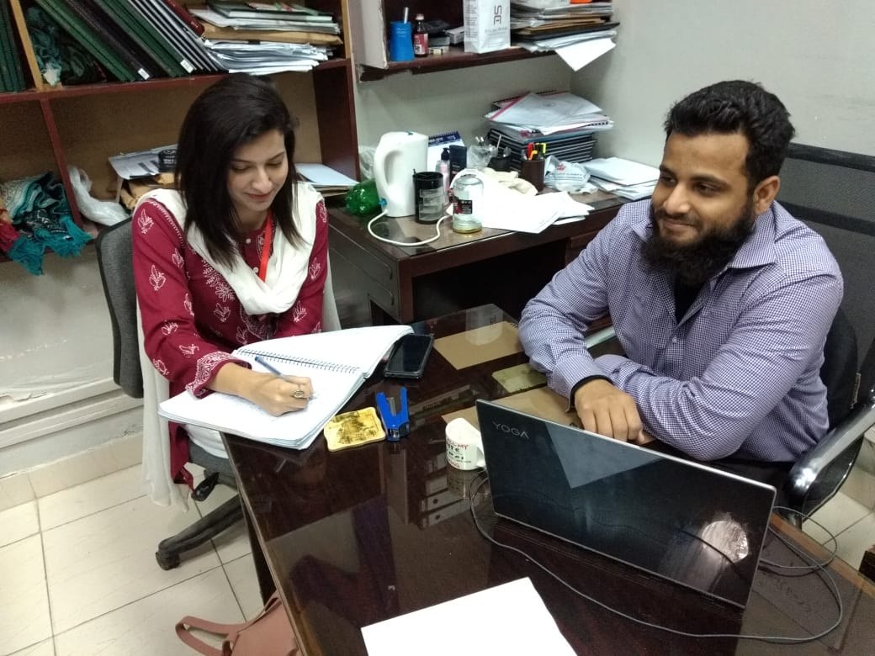 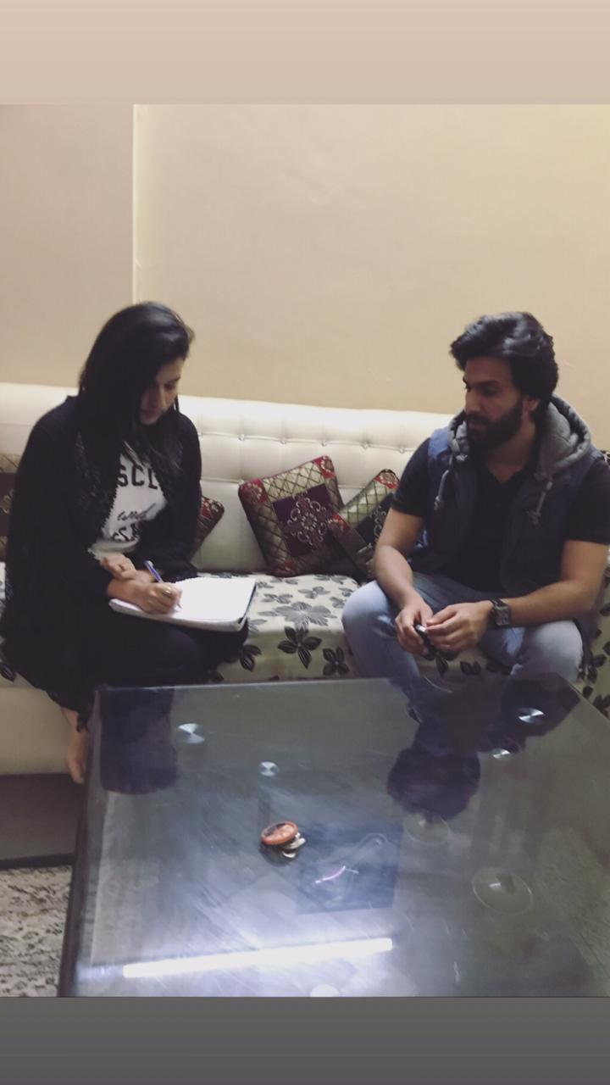

Service Seeker (Client) Service Provider

# Storyboard Design:

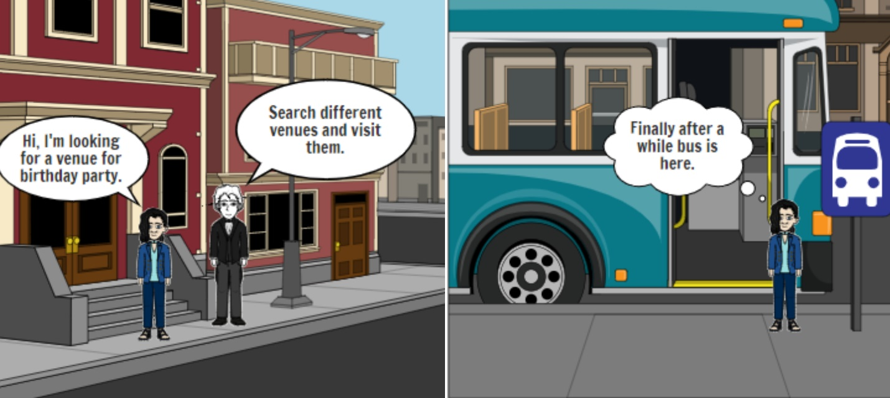

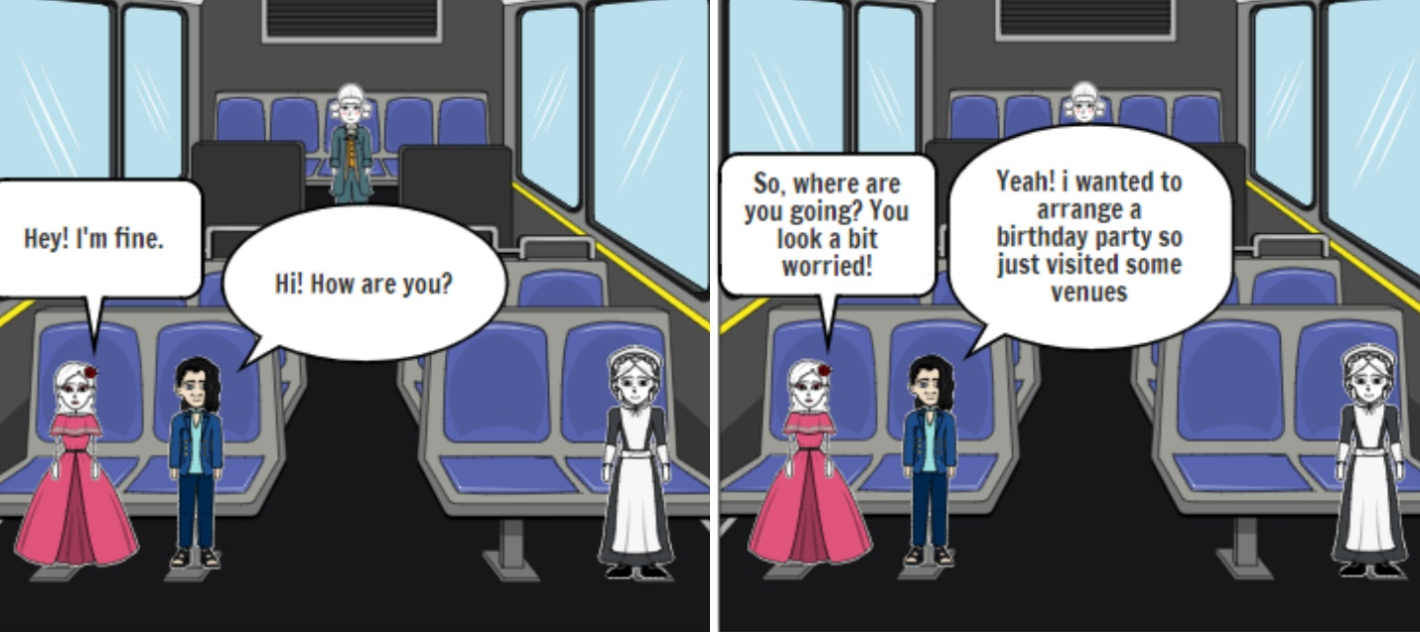

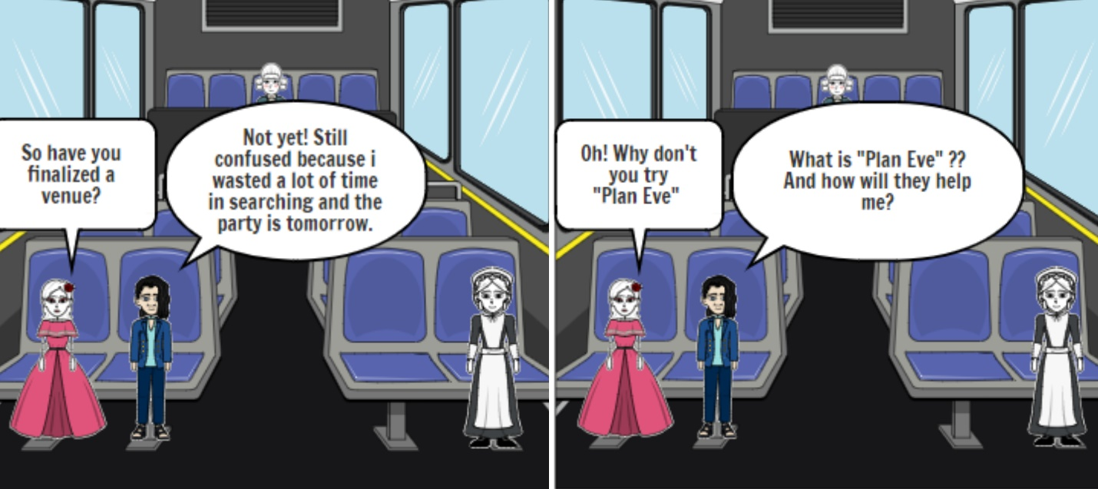

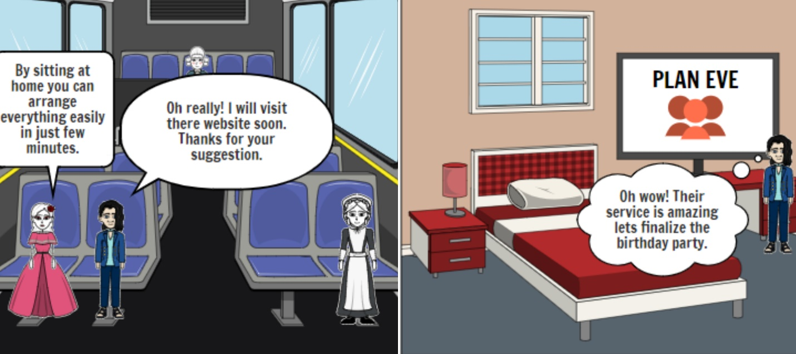

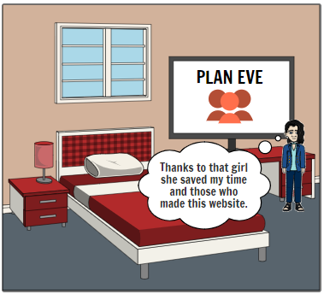

# Hierarchical Task Analysis Diagram:

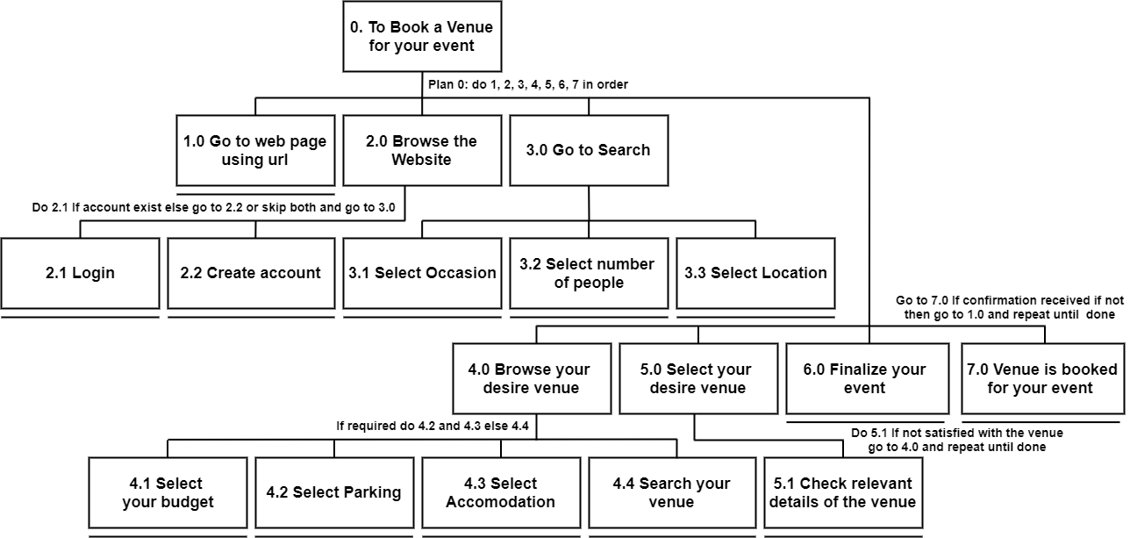

# Interactive Prototype:

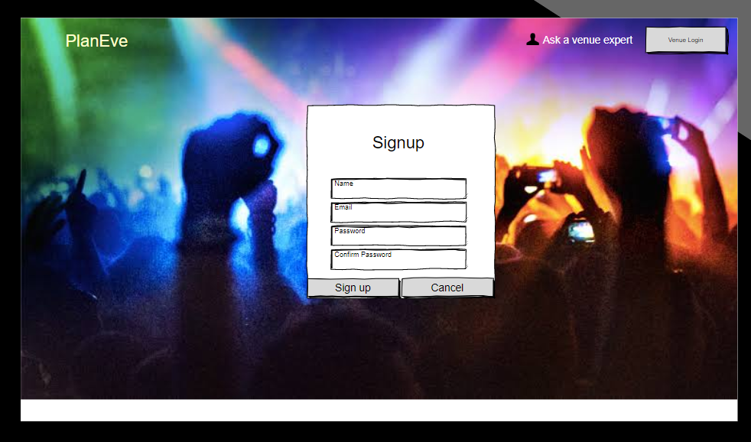

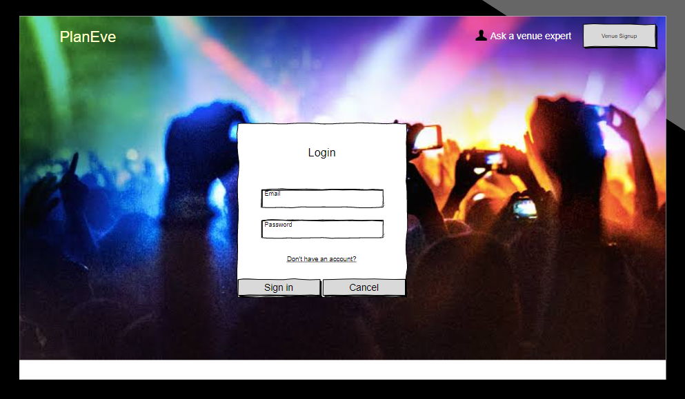

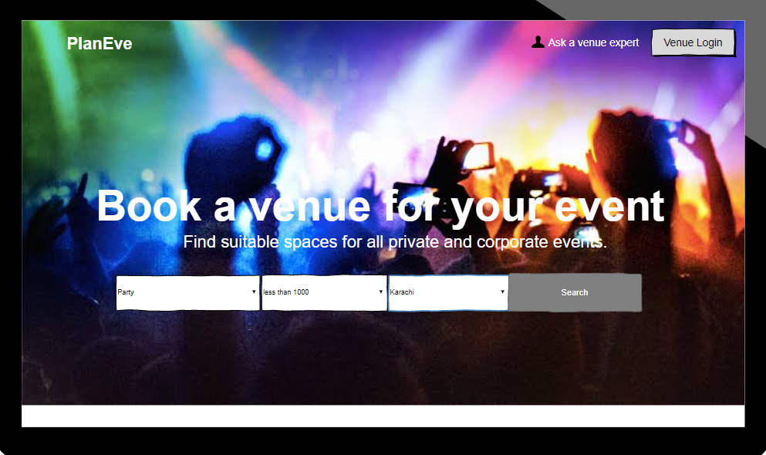

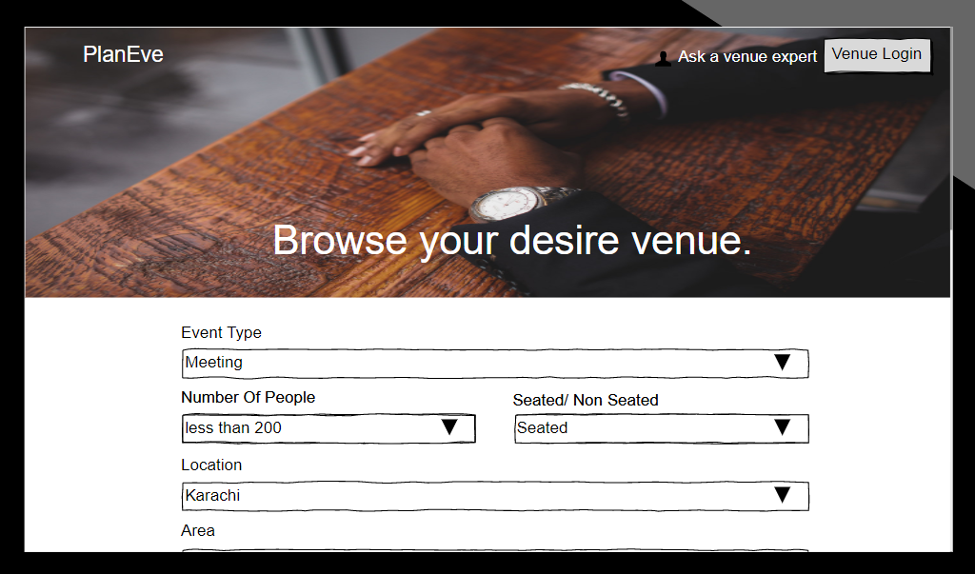

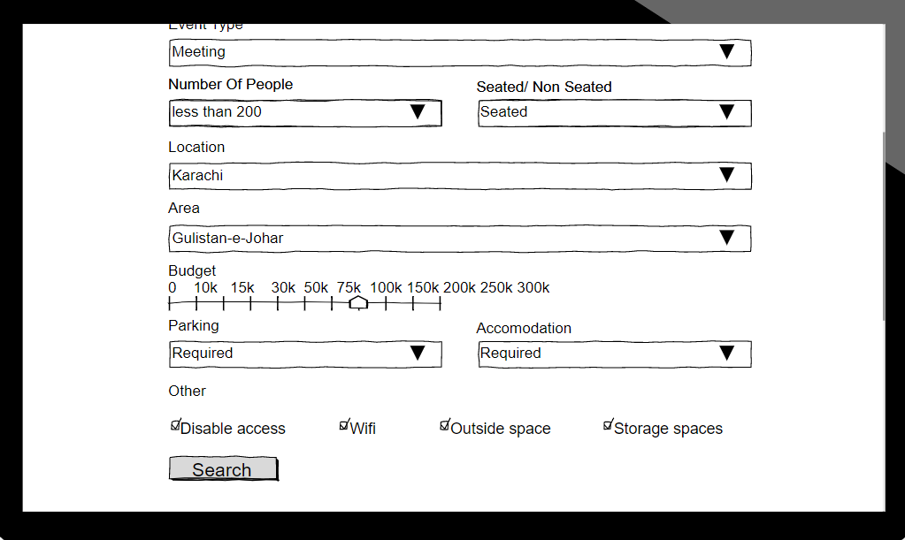

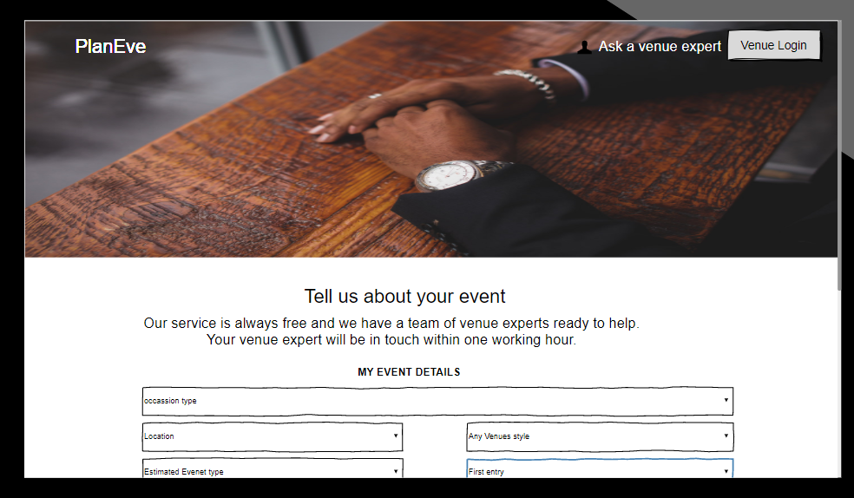

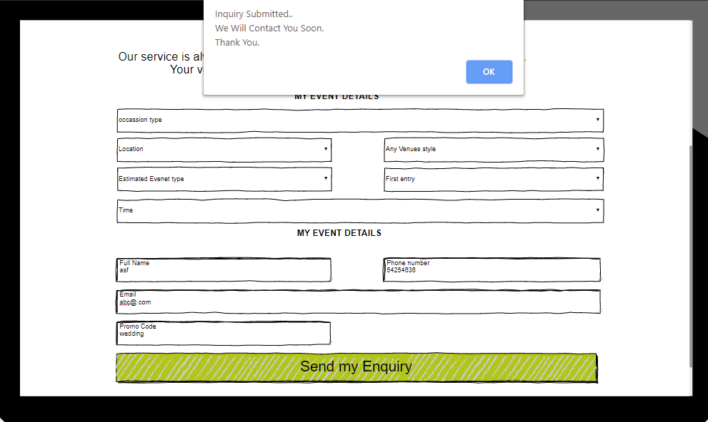

## Evaluation of Prototype:

We have use Jakob Nelson’s 10 principles to evaluate the prototype.

|  |  |  |
| --- | --- | --- |
| **Principles** | **Yes or No** | **Reason** |
| Visibility of the system | Yes | Each functionality is visible |
| Match between real world | Yes | Yes, it’s like real world |
| User Control | Yes | User can control this system |
| Consistency and standard | Consistent | All pages follow the same template |
| Error Prevention | Yes |  |
| Recognition rather than recall | No |  |
| Flexibility and efficient of use | Yes |  |
| Aesthetic and minimalist | No aesthetic | Yes minimalist |
| Help and documentation | No | No guideline is needed |
| Recover from recognize and error | Yes |  |